ASSIGNMENT 4

Verifying Design With Unit Tests, UI Navigation

Due: Week 8

# Task 1 - GPS Coordinate Unit Tests

## 1.1

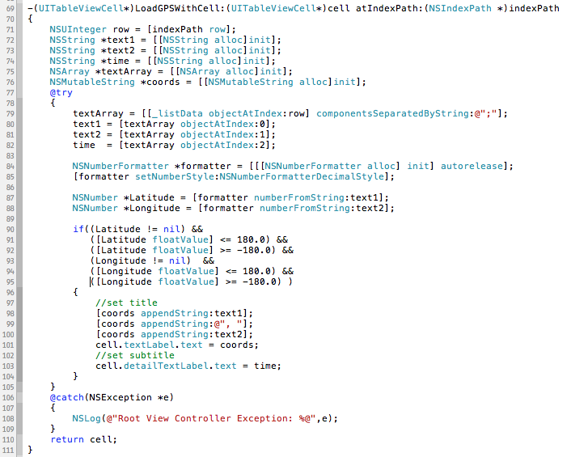

This method is called in - (UITableViewCell *)tableView: cellForRowAtIndexPath: to load data to uitableview

## 1.2

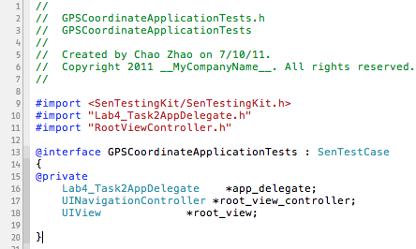

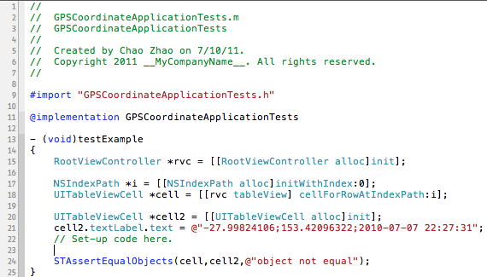



## 1.3

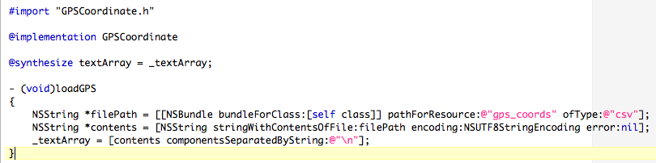

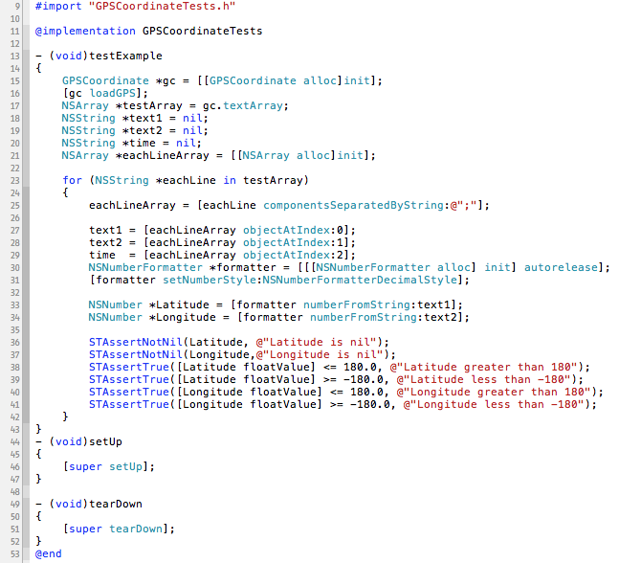

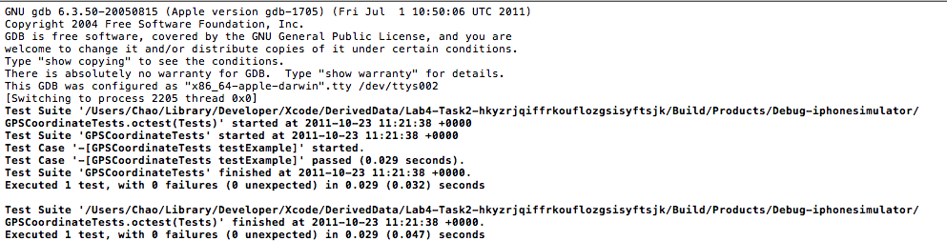

# Task 2 – Test Your Assumptions

Unit test is used to test each smallest unit in the project. It can make sure each unit works. Also unit test can test each method running times. It can offer the performance report to developer.

The benefit of unit tests is to test smallest part of large project. With the unit tests, developer can write codes, then just hit test button to run test, and within a few seconds. They have the results. It tells that what passed or failed and at which line. The developers can exactly what need to work on. Also, doing Test Driven Development when developing is one of the best ways to keep track of the works.

In real world, we may need to develop the application deal with external data source, likes human input, read from file and external file from internet. This file contents may be not correct. When the data input to the application. It may crash the application. It will bring bad user experience to users. We need make application can handle all data from external data source.

For instance, application can register user. Users need type their email and password and verified password to application. To handle the email input, we need check is this right format of email. Email format is combine by username, @ and domain name. Users’ password should have at least 8 characters. Verified password should exactly as the first password text field.

To test user’s password is easy, we should need check the number of use input’s characters are greater than 8 and they are exactly same.

To verify users’ email, we can

According to our business rules, the valid characters are only letters (A to Z), numbers, underscore and stop period.

The legal email address could look like these:

* hello_world@example.com
* user001@example.com
* hellowworld@example.com

@ characters: check @ position is greater than 0 and less than last position.

The domain name: must at least one stop period in the domain name.

# Task 3 - Embedded Navigation

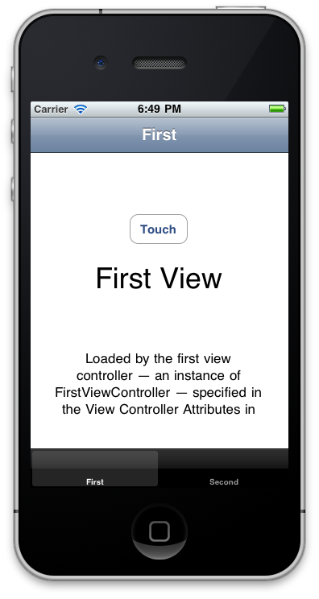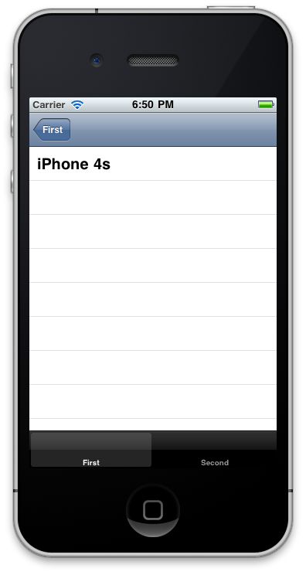

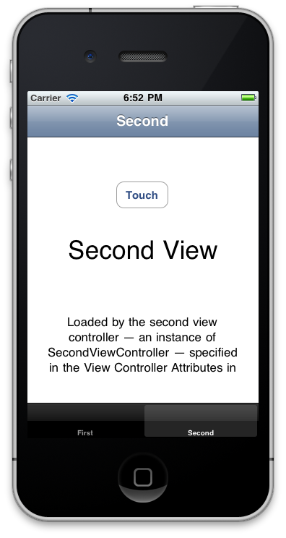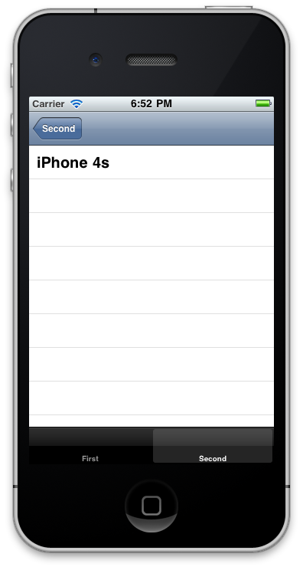

Above 4 screenshots show that Navigation Controller and its sub view: UITableViewController.

This project is created by Tab Bar Application template. I dragged two Navigation Controllers from utilities to the MainWindows.xib file. I delete the View Controller in the Navigation Controller and drag original View Controller in Navigation Controller as the Navigation Controller’s child. It likes like this

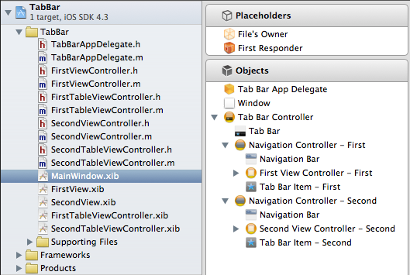

Drag a button in FirstViewController.xib, connect the action with button in File’s Owner.

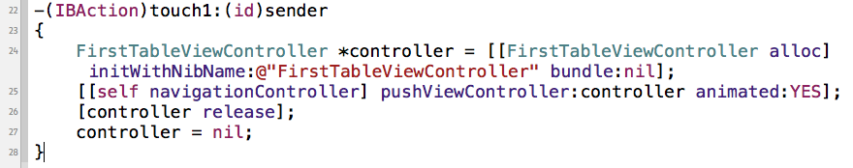

This above method will display the FirstTableViewController to users. Also I import the FirstTableVIewControll.h in hear file. FirstTableViewController and SecondTableViewController are subclass of UITablViewController.

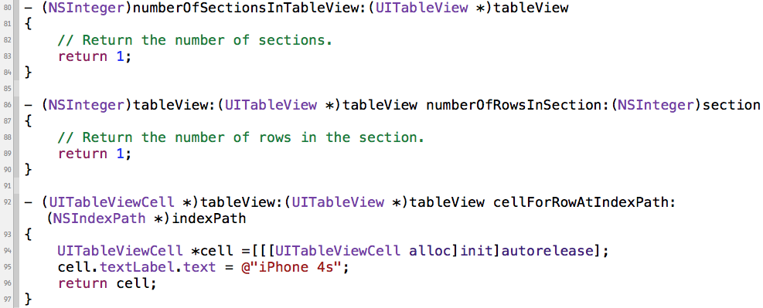

The above methods show that how UITableView display the data source. In the line 92 – 97, I did not reuse the UITableViewCell, because there is only on row in UITableView.